# Chapter 1

**1.1 Introduction**

________________________________________________________________________

A tiffin ordering system is referred to as a set of detail methods that is being used in handling the tiffin ordering process. Tiffin ordering can be computerized or done manually. Those helps the users to choose their tiffin themselves which is known as the users self-ordering system.

The users self-ordering system can be defined as a computerized system that is being used by users to choose their own tiffins and allow the tiffins to be tracked, in order to prepare and deliver the tiffins to the customers.

* My Tiffin( Online Tiffin Ordering Portal ) is a web application built in PHP,HTML and CSS.
* The online tiffin ordering system will become one of the famous services that the tiffin providers and users will be using in the future.
* Tiffin ordering can be computerized or done manually.
* This connects the various tiffin providers with the students/professionsls etc withiout going anywhere else.
* This web application is especially beneficial for students/professionsls etc who are away from their family. All they need to do is choose and order their tiffin and enjoy the meal without having the need to prepare it themselves.
* Main aim of this web application is to make an user friendly platform where, various tiffin providers and tiffin users can interact with each other.
* It is accessible to everyone who are interested.

**1.2**

**Modules:**

|  |  |  |  |  |  |  |
| --- | --- | --- | --- | --- | --- | --- |
| |  |  |  | | --- | --- | --- | | Provider | The person or the group who provides the tiffins. |  | | User | Who uses the tiffins provided |  | |
|  |
|  |
| **Functionality:** |
| |  |  | | --- | --- | | Provider | * View Data of Registered Users * Change the daily Menu. * Customize tiffin. * Can add more areas within their service. | | User | * View Daily Tiffin Menu * Update his/her Personal Details * Can subscribe to provider's meal plan * Can check the availability of service in his/her area | |

**1.3**

**Functional Requirement:**

|  |  |  |  |  |
| --- | --- | --- | --- | --- |
| |  |  | | --- | --- | | Administrator | * View Data of Registered Users * Change the Daily Menu * Can Add more areas within Service | | User | * Can Subscribe to Meal plan * View Daily Tiffin Menu * Update their Profile * Can Check the Availability of service in his/her Area | |

**Chapter 2 Scope**

_____________________________________________________________________________

* The scope of the "MY TIFFIN" (Online Tiffin Ordering Portal) includes: Ordering tiffin online, view and select the tiffin of user's choice,allow the provider to expand their service and update the daily tiffin menu.
* The basic scope of the project is given as under.

User’s Area and concern.

Provider’s Panel.

* The purpose of designing the "MY TIFFIN" (Online Tiffin Ordering Portal) is to provide the user a platform where he can choose the tiffin from various providers on our website, without any need to prepare food or go to outside restaurant to enjoy meal.
* It also connects the modern day requirements of today’s people.

**Chapter 3 Software/Hardware Requirements Specification**

________________________________________________________________________

**Hardware Requirements:**

• **Processor** : Intel Pentium And Above Version

• **Speed** : 1.60 GHz and Above

• **Hard Disk** : 20GB And Above

• **Key Board** : Standard 2.4

**Software Requirements:**

• **Operating System** : Windows 7 and Above

• **Data Base** :MySQL

• **Tools** : PHP,HTML,CSS

**Chapter 4 ER Diagram**

________________________________________________________________________

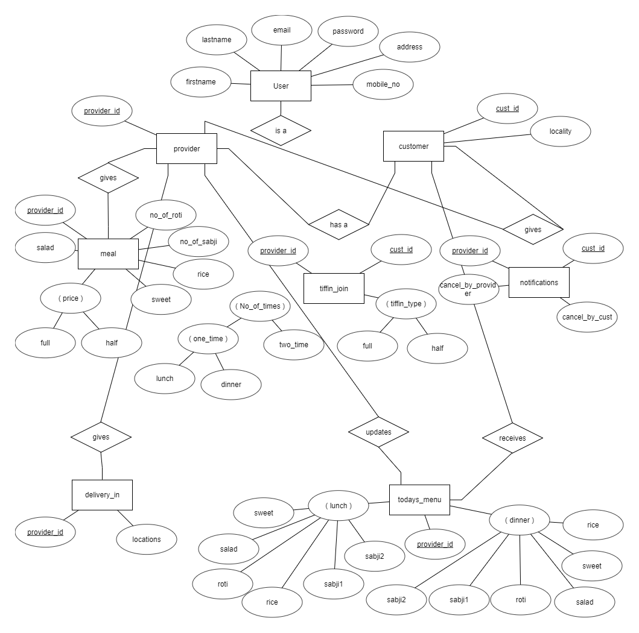

**Chapter 5 Relational Database Design**

________________________________________________________________________

* User registration

|  |  |
| --- | --- |
| firstname | Insert firstname in user table |
| lastname | Insert lastname in user table |
| password | Insert Password in user table |
| password again | Insert Password again in user table |
| email | Insert email in user table |
| mobile no | Insert mobile no in user table |
| address | Insert address in user table |
| locality | Insert locality in user table |

* Provider's registrtion

|  |  |
| --- | --- |
| firstname | Insert firstname in provider table |
| lastname | Insert lastname in provider table |
| password | Insert Password in provider table |
| password again | Insert Password again in provider table |
| email | Insert email in provider table |
| mobile no | Insert mobile no in provider table |
| address | Insert address in provider table |
| tiffin name | Insert tiffin name in provider table |
| Veg/non-veg | Insert veg/non-veg in provider table |
| Kothrud | Tick the checkbox if deliver in this area is in provider table |
| Karvenagar | Tick the checkbox if deliver in this area is in provider table |
| Deccan | Tick the checkbox if deliver in this area is in provider table |
| J M Road | Tick the checkbox if deliver in this area is in provider table |
| Bavdhan | Tick the checkbox if deliver in this area is in provider table |
| Swargate | Tick the checkbox if deliver in this area is in provider table |
| Law College Road | Tick the checkbox if deliver in this area is in provider table |
| Warje | Tick the checkbox if deliver in this area is in provider table |

* Userlogin

|  |  |
| --- | --- |
| username | Retrieve email from user table |
| password | Retrieve password from user table |

* Providerlogin

|  |  |
| --- | --- |
| username | Retrieve email from provider table |
| password | Retrieve password from provider table |

* TiffinJoin

|  |  |
| --- | --- |
| User_id | Insert user id from user table in tiffin join table |
| Provider_id | Insert provider id from user table in tiffin join table |
| Radio_1 | Insert boolean value to check whether tiffin joined by user is 2 times or 1 time |
| Radio_2 | Insert boolean value to check whether 1 time tiffin joined by user is for lunch or dinner |
| Full_half | Insert boolean value to check whether tiffin joined by user is full or half |

* Meal

|  |  |
| --- | --- |
| Id | Insert provider_id in meal tiffin |
| Full_price | Insert price of full tiffin in meal table |
| Half_price | Insert price of half tiffin in meal table |
| No_roti | Insert number of roties in meal table |
| No_sabji | Insert number of sabjies in meal table |
| Rice | Tick the checkbox if proider wants to provide rice |
| Salad | Tick the checkbox if proider wants to provide salad |
| Sweet | Tick the checkbox if proider wants to provide sweet |

**Chapter 6 Data Dictionary**

________________________________________________________________________

|  |  |  |
| --- | --- | --- |
|  | **User Registration** |  |
| firstname | Firstname | Varchar(20) |
| lastname | Lastname | Varchar(20) |
| username | Email Id | Varchar(40) |
| password | Password | Varchar(32) |
| mobile | Mobile no | Big Int |
| address | Address | Varchar(200) |
| locality | Locality | Varchar(20) |

|  |  |  |
| --- | --- | --- |
|  | **Provider Registration** |  |
| firstname | Firstname | Varchar(20) |
| lastname | Lastname | Varchar(20) |
| username | Email Id | Varchar(40) |
| password | Password | Varchar(32) |
| mobile | Mobile no | Big Int |
| address | Address | Varchar(200) |

|  |  |  |
| --- | --- | --- |
|  | **Full_meal Table** |  |
| Id | Provider id | Int |
| full_price | Full tiffin Price | Int |
| half_price | Half tiffin price | Int |
| no_roti | No of roti | Int |
| no_sabji | No of sabji | Int |
| rice | Rice | boolean |
| salad | Salad | Boolean |
| sweet | Sweet | Boolean |

|  |  |  |
| --- | --- | --- |
|  | **Half_meal Table** |  |
| Id | Provider id | Int |
| full_price | Full tiffin Price | Int |
| half_price | Half tiffin price | Int |
| no_roti | No of roti | Int |
| no_sabji | No of sabji | Int |
| rice | Rice | boolean |
| salad | Salad | Boolean |
| sweet | Sweet | Boolean |

|  |  |  |
| --- | --- | --- |
|  | **Tiffin_join** |  |
| user_id | User Id | Int |
| radio-1 | 2 or 1 Time Tiffin | Boolean |
| radio-2 | Lunch or Dinner | Boolean |
| no_roti | No of roti | Int |
| no_sabji | No of sabji | Int |

|  |  |  |
| --- | --- | --- |
|  | **Delivery** |  |
| kothrud | Kothrud | Boolean |
| karvenagar | Karvenagar | Boolean |
| deccan | Deccan | Boolean |
| jmroad | J M Road | Boolean |
| swargate | Swargate | Boolean |
| lawcollegerod | Law College Road | Boolean |
| bavdhan | Bavdhan | Boolean |
| warje | Warje | Boolean |

|  |  |  |
| --- | --- | --- |
|  | **Today's_menu** |  |
| provider_id | Provider Id | Int |
| l_roti | Type of roti in lunch | Varchar(20) |
| d_roti | Type of roti in dinner | Varchar(20) |
| l_sabji1 | Type of sabji 1 in lunch | Varchar(20) |
| d_sabji1 | Type of sabji 1 in dinner | Varchar(20) |
| l_sabji2 | Type of saji 2 in lunch | Varchar(20) |
| d_sabji2 | Type of sabji 2 in dinner | Varchar(20) |
| l_rice | Type of rice in lunch | Varchar(20) |
| d_rice | Type of rice in lunch | Varchar(20) |
| l_salad | Yes if Salad is present in lunch | Varchar(20) |
| d_salad | Yes if Salad ispresent in Dinner | Varchar(20) |
| l_sweet | Yes if Sweet is present in lunch | Varchar(20) |
| d_sweet | Yes if Sweet is present in Dinner | Varchar(20) |

|  |  |  |
| --- | --- | --- |
|  | **Notification** |  |
| user_id | User's id | Int |
| provider_id | Proovider's id | Int |
| user_cancel | 1 if user cancel's tiffin | Boolean |
| provider_cancel | 1 if provider cancel's tiffin | Boolean |

**Chapter 7 Data Normalization**

Data Normalization is basically the process of oranising the columns that is attributes and tables that is relation of a relational database to reduce data redundancy and to improve data integritiy.

It involves arranging attributes in relations based on dependencies between attributes,ensuring that the dependencies are properly enforced by dtabes integrity constraints.

Avoiding data normalization can lead to anomalies which are inconvenient and error prone situations arising when we process the table.

Types of Anomalies:

Update Anomaly- An **Update Anomaly** exists when one or more instances of duplicated data is updated, but not all.

Delete Anomaly- A **Delete Anomaly** exists when certain attributes are lost because of the deletion of other attributes.

Insert Anomaly- An **Insert Anomaly** occurs when certain attributes cannot be inserted into the database without the presence of other attributes.

In this project we have maintained data normalization which has led to less data redunduncy and more data integrity. We have totally avoided duplication of data and hence we have avoided all the types of anomalies. User ID and Provider ID are the primary keys we have used in all the tables to differentiate the data of various providers and users, hence maintaining data integrity .

**Chapter 8 Graphical User Interface**

**1.Homepage**

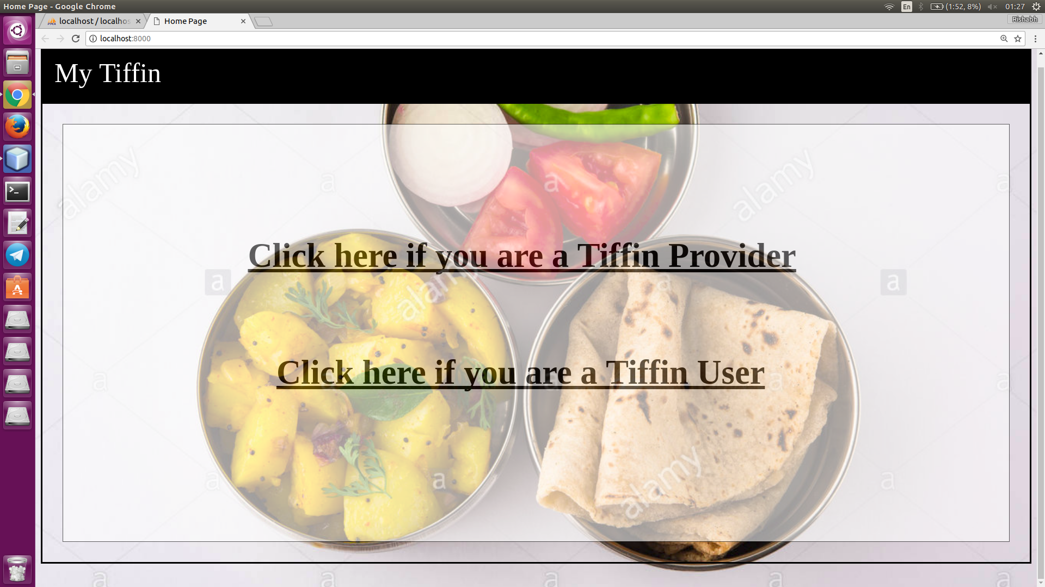

**2 Provider Login**

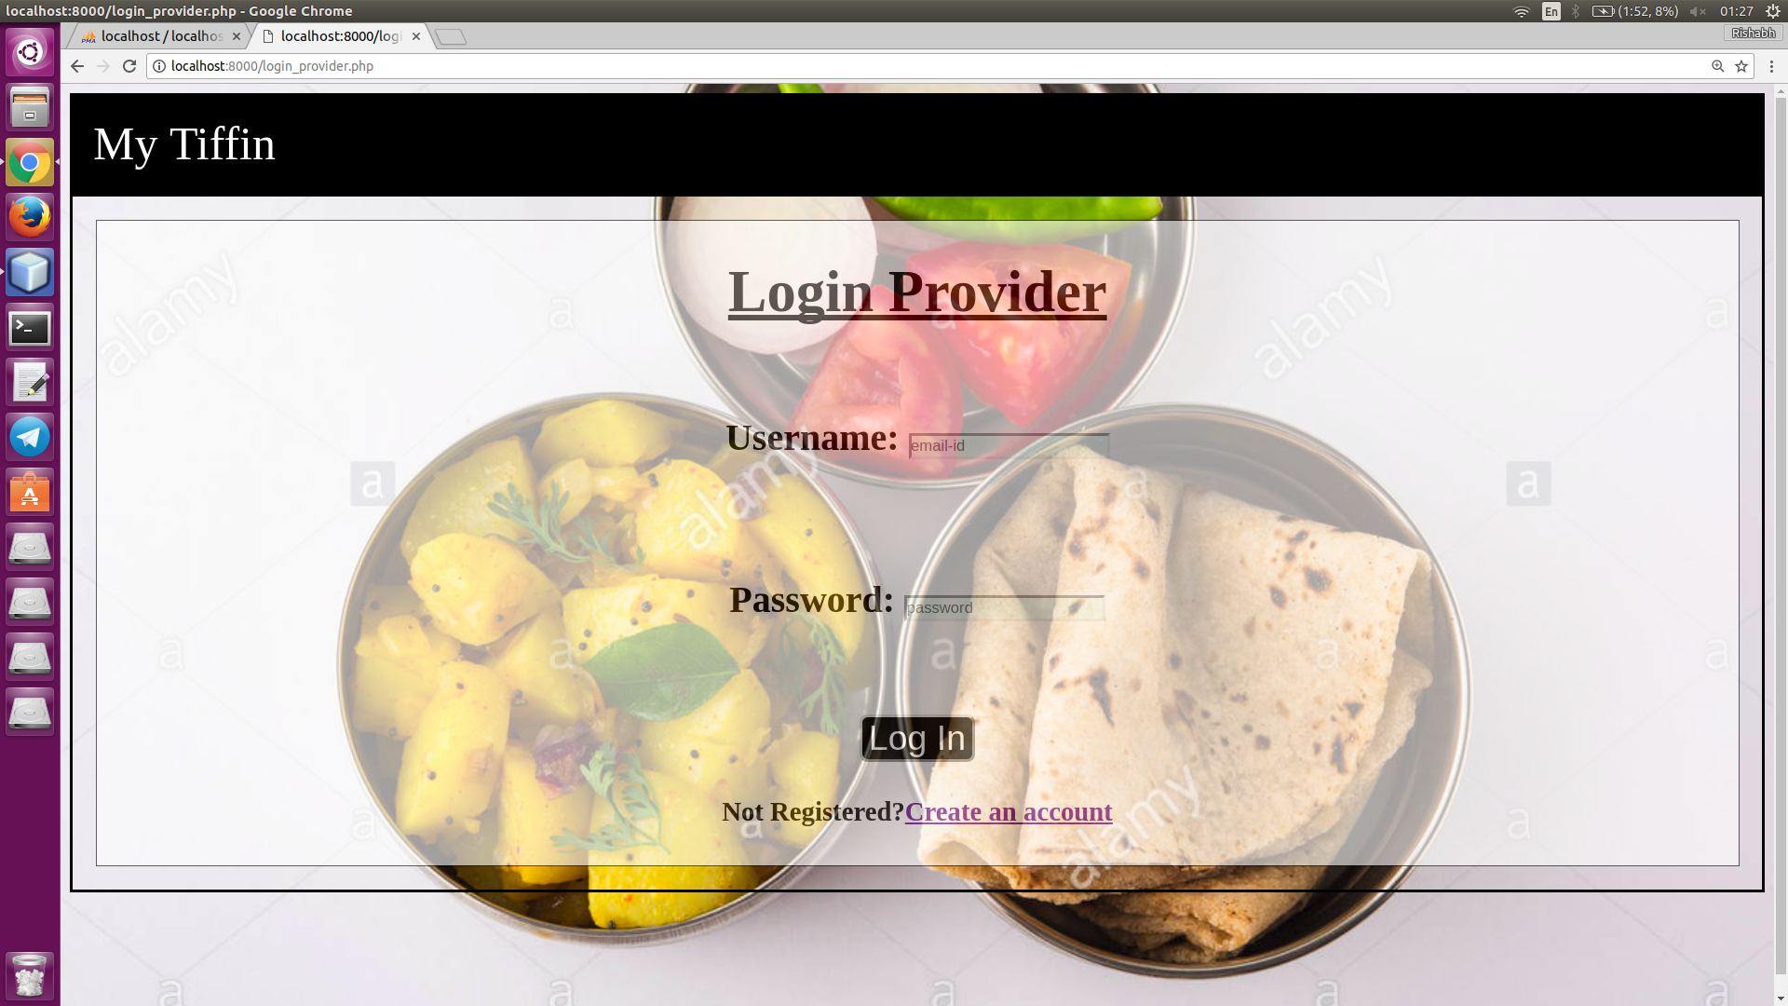

**3.Provider Registration page**

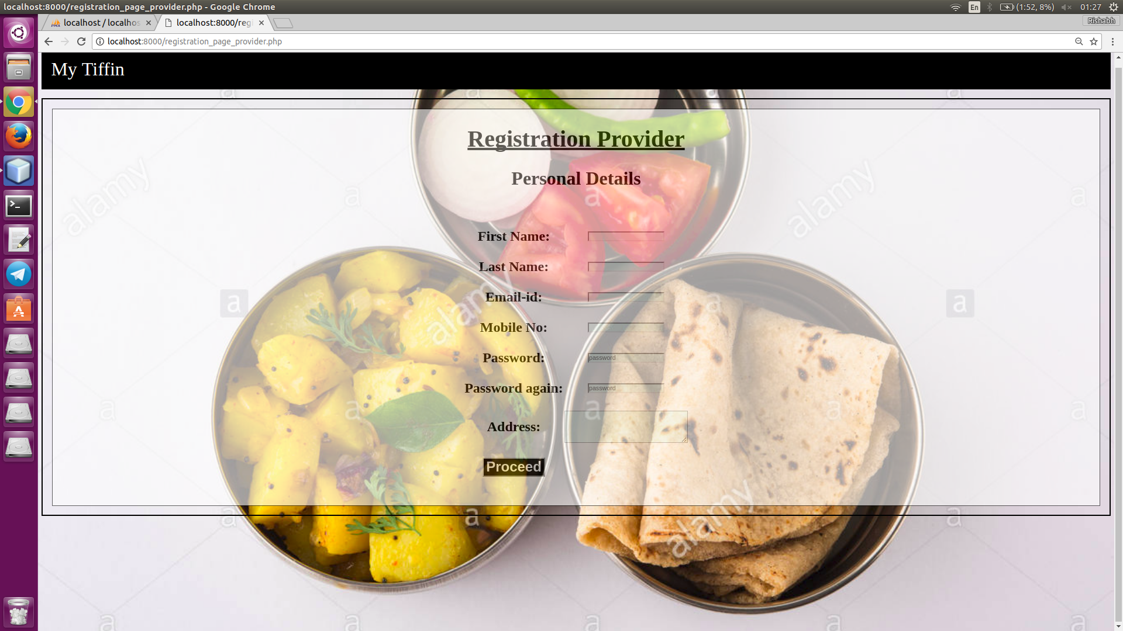

**4. Provider Registration page2**

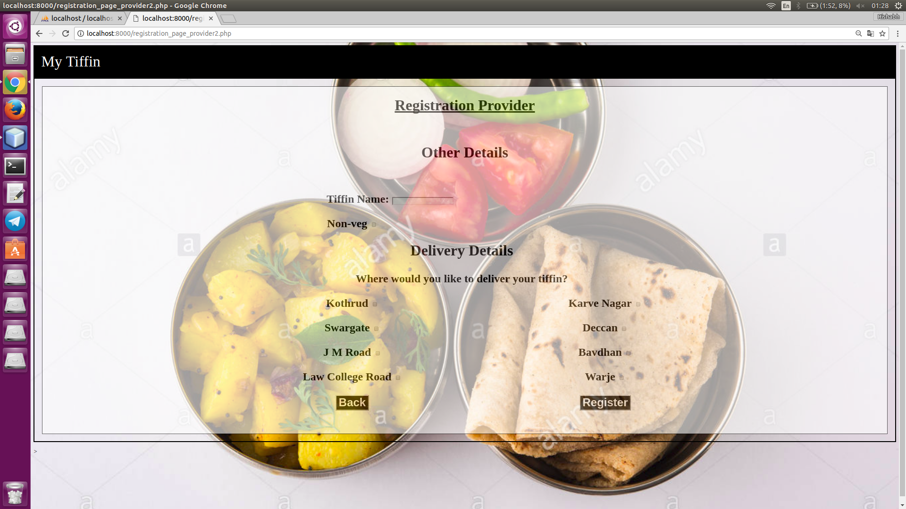

**5. Provider Home Page**

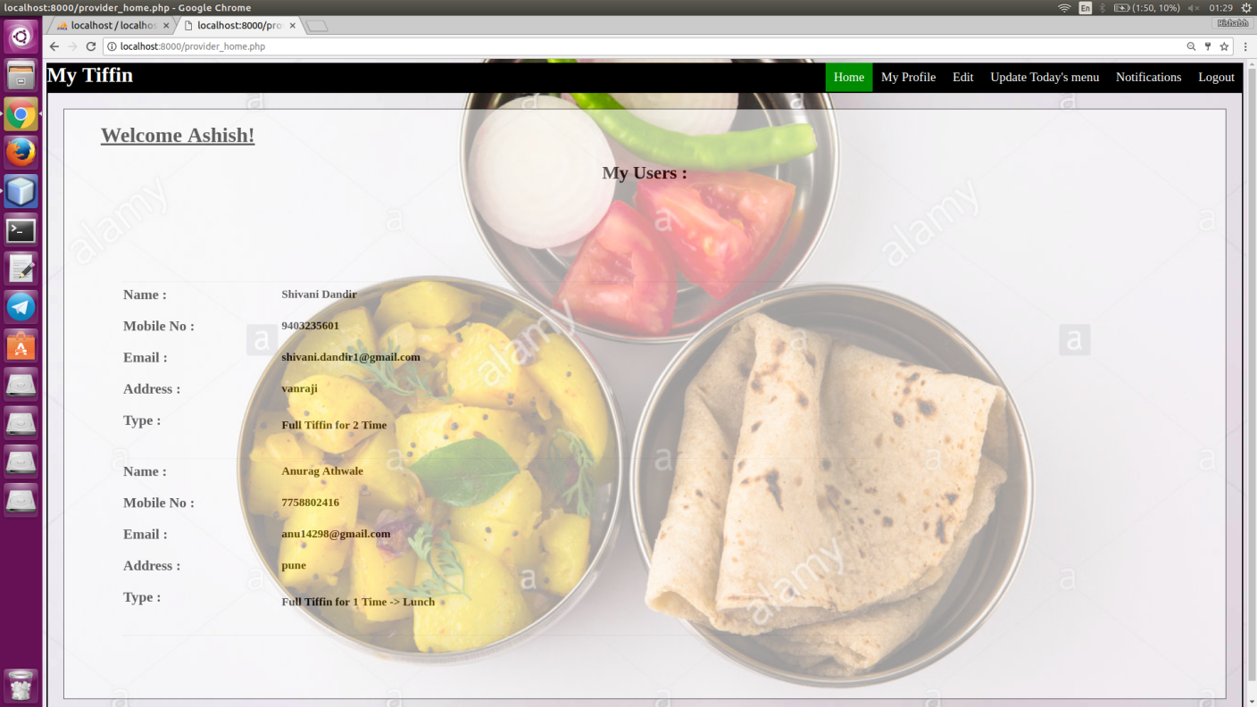

**6. Provider Profile**

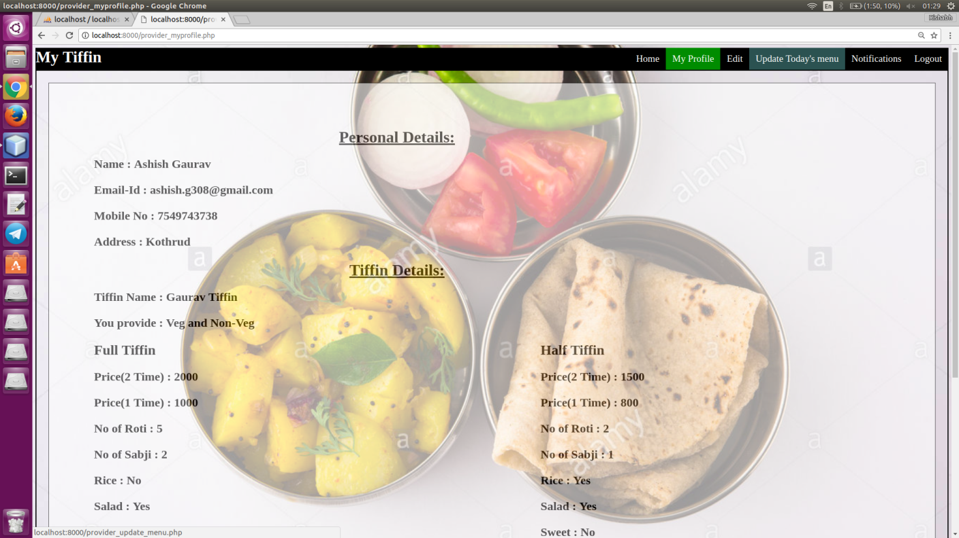

**7. Provider Edit Tiffin Details**

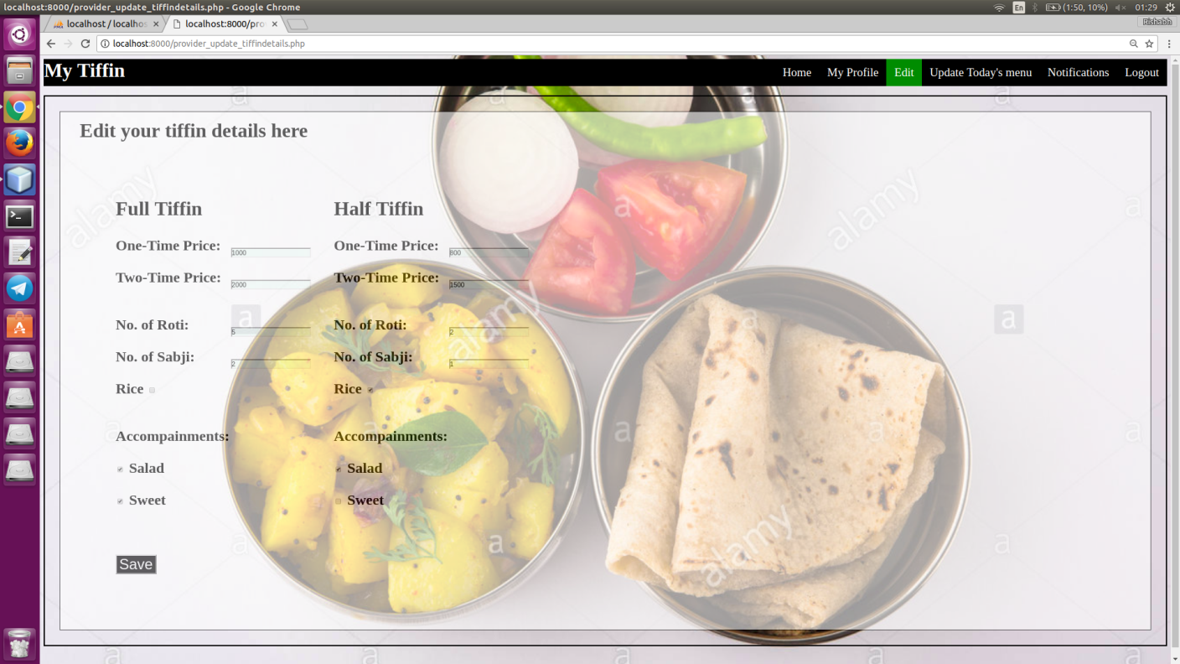

**8. Provider Edit Personal Details**

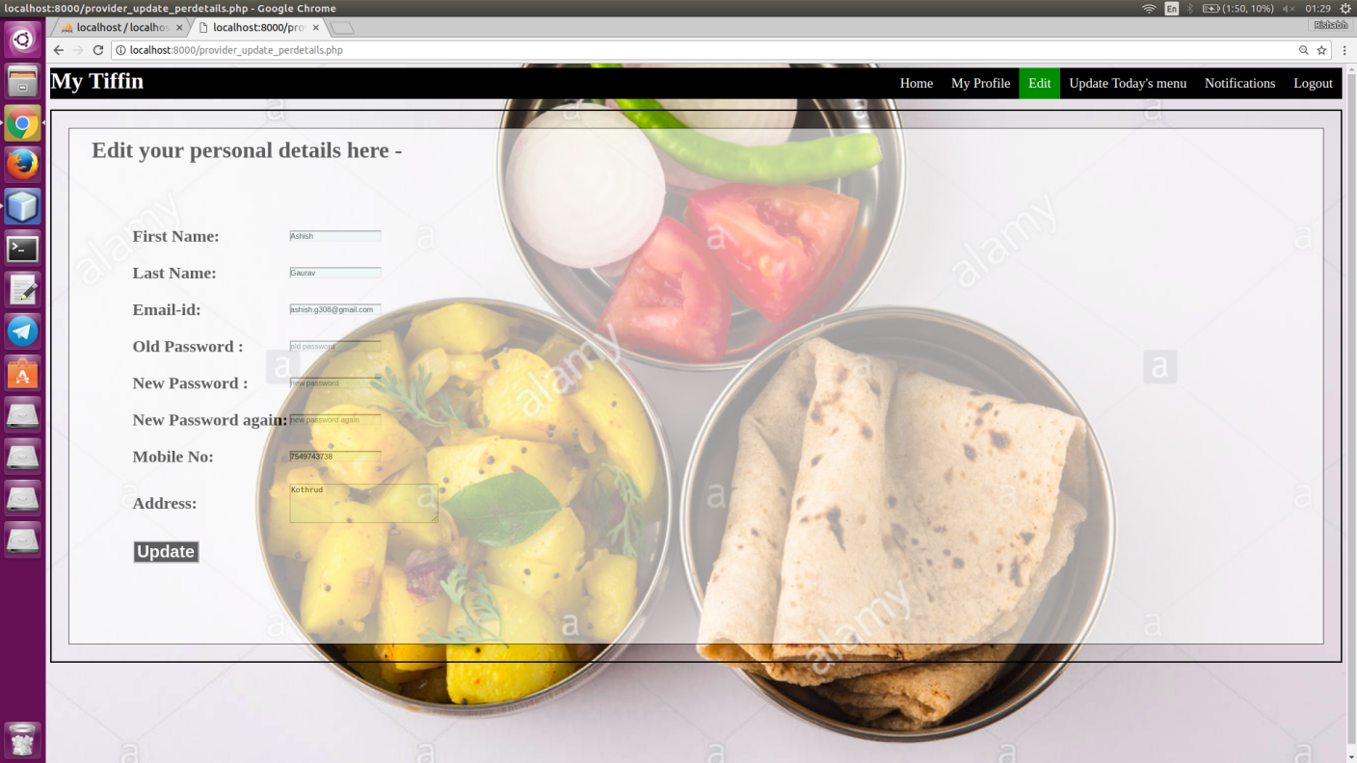

**9. Provider Edit Delivery Details**

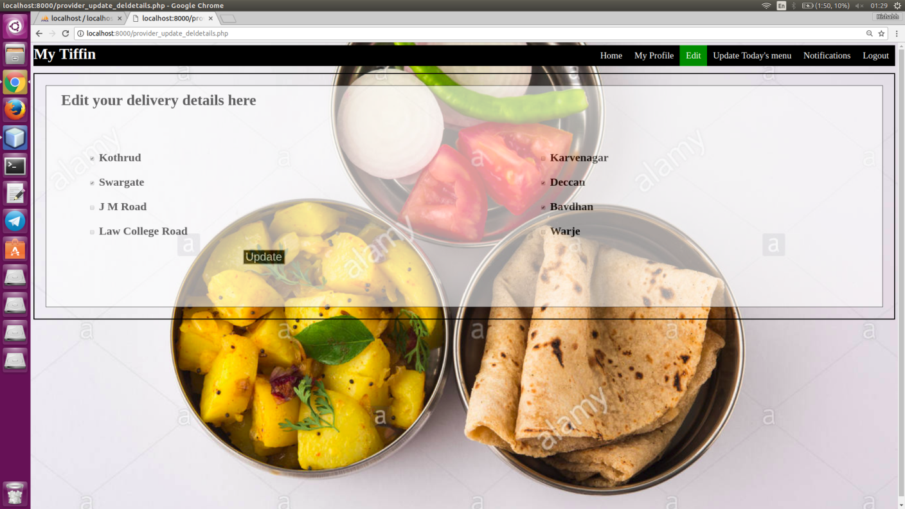

**10.Provider Update Today's Menu**

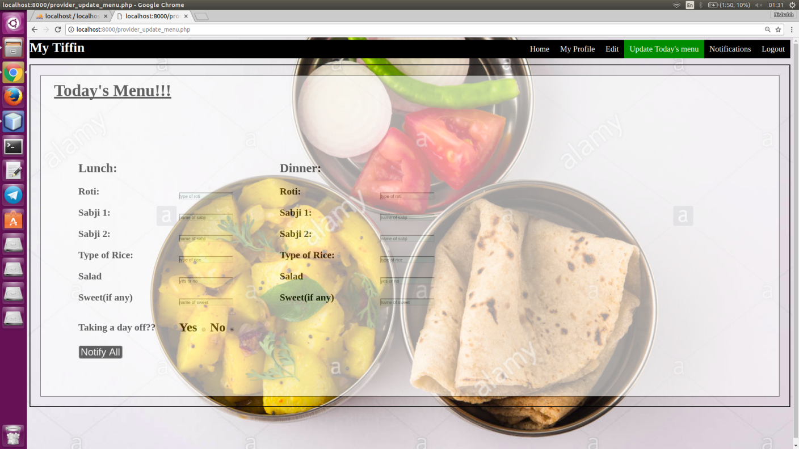

**11.Provider Notification**

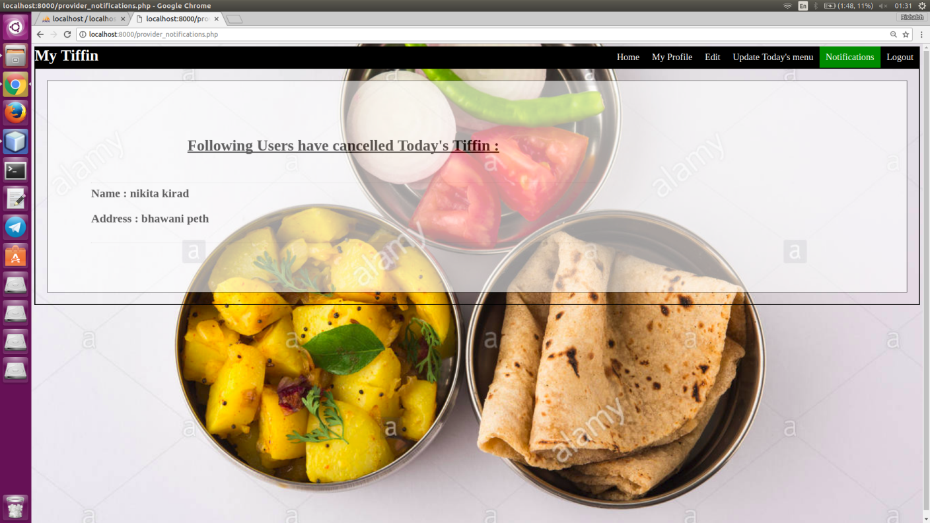

**12. User Login**

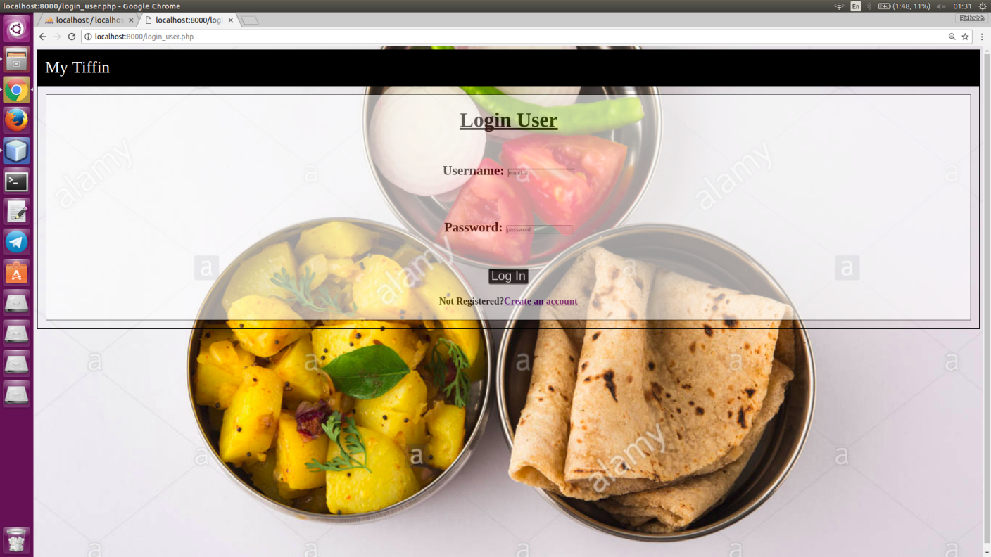

**13. User Registration Page**

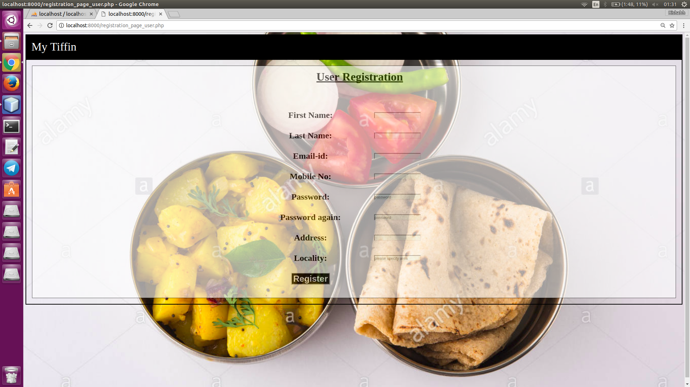

**14. User Home Page**

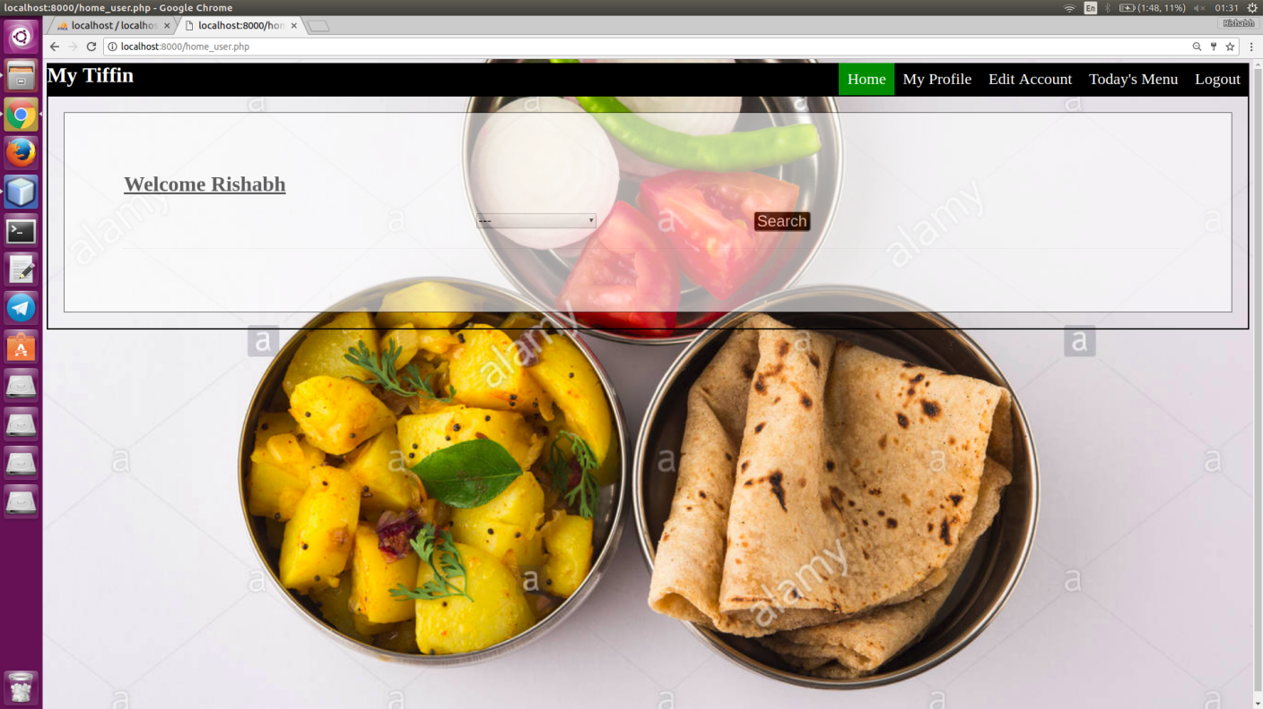

**15. User Home Page 2**

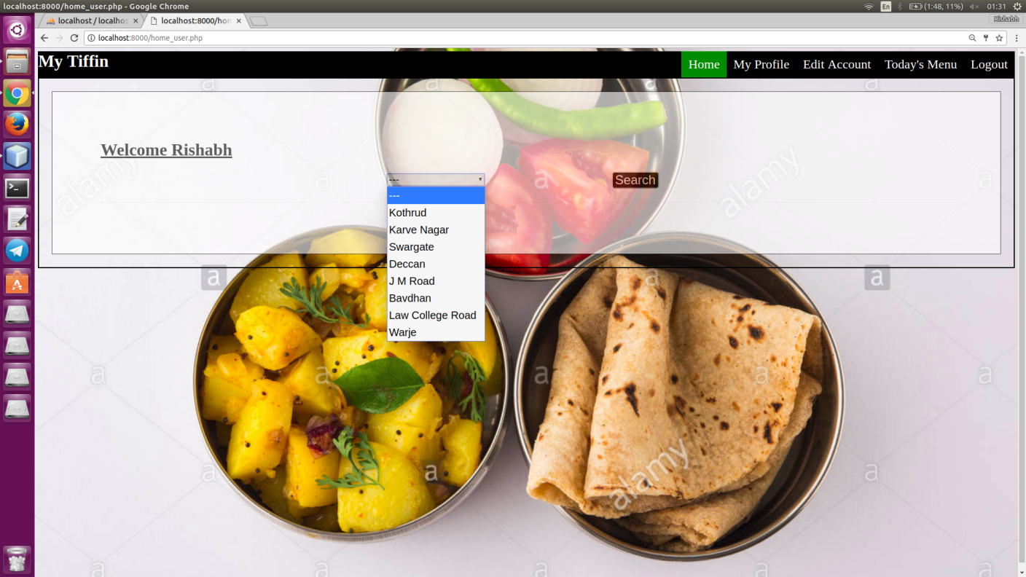

**16. User Home Page 3**

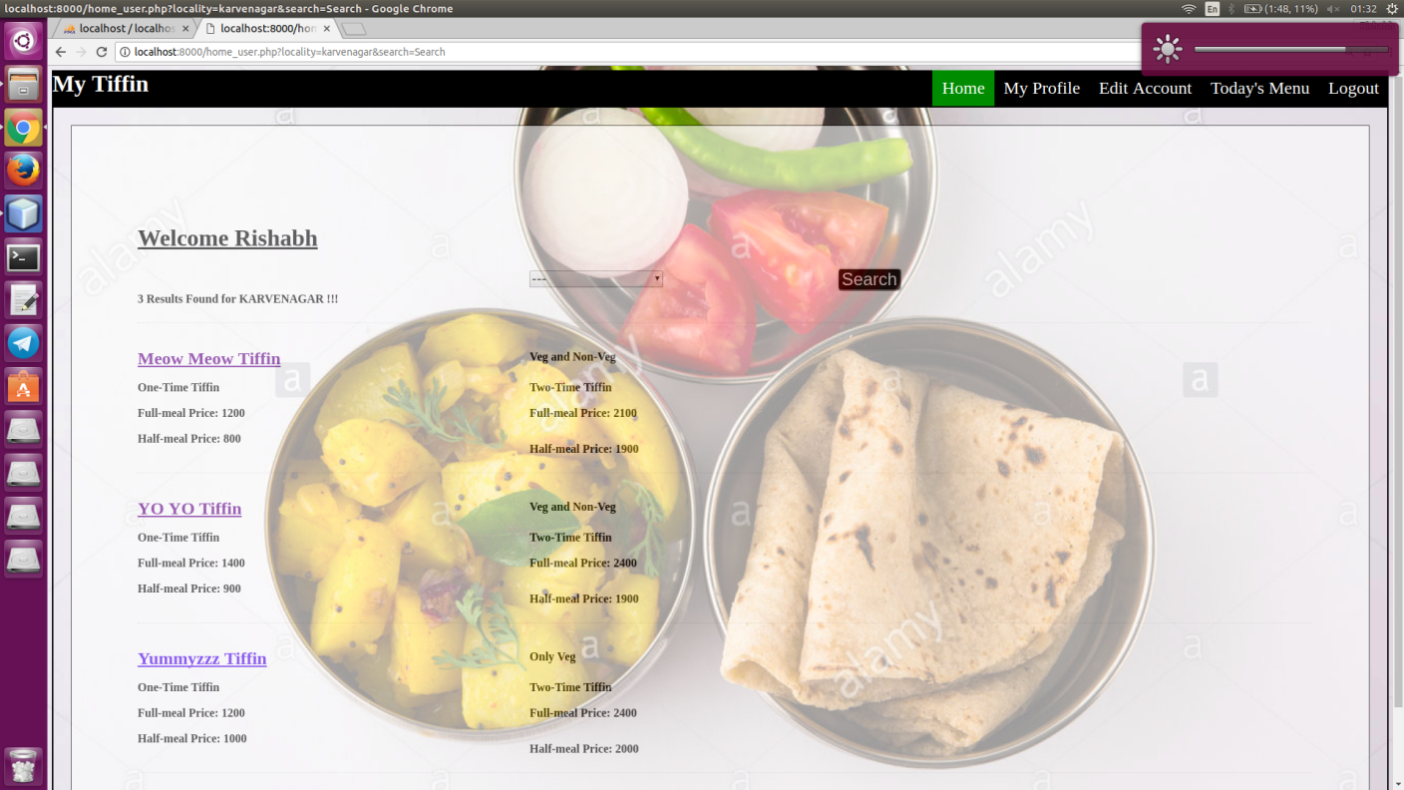

**17. Searched Tiffin Details**

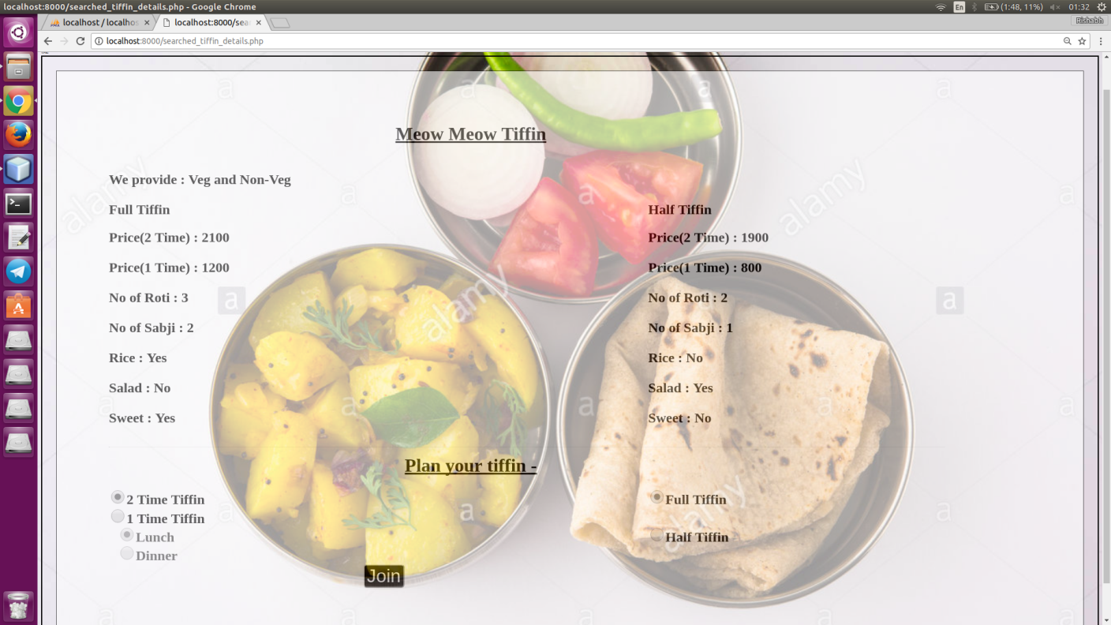

**18. User Profile**

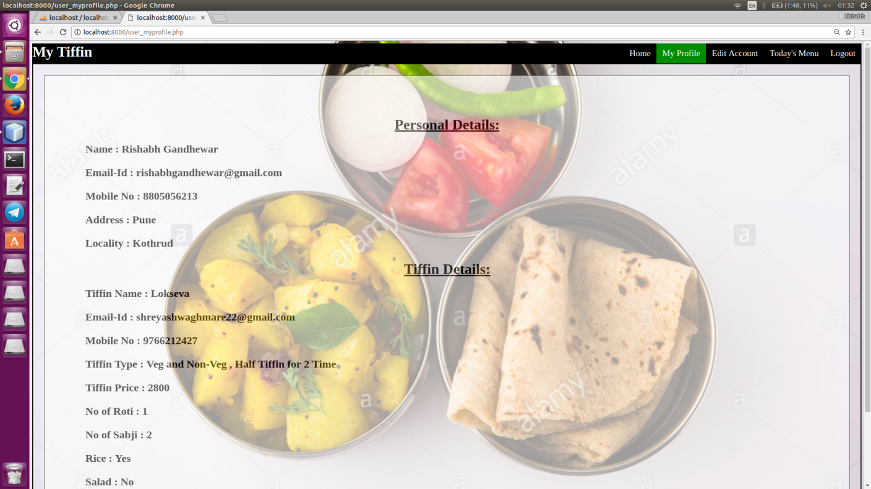

**19.Edit Account**

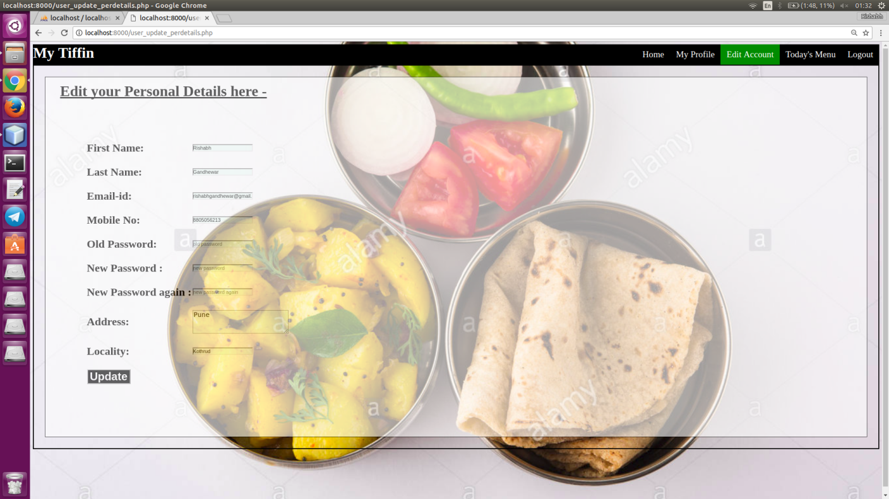

**20.User Todays's Menu**

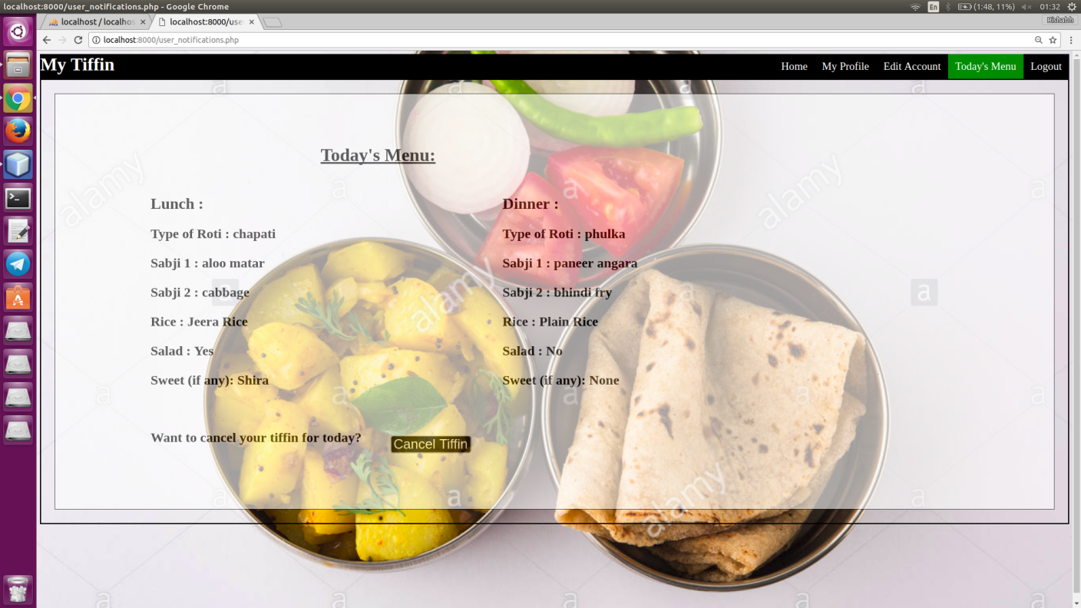

**Chapter 8 Conclusion**

________________________________________________________________________

Here, I have designed a project “My Tiffin" (Online Tiffin Ordering Portal)” using PHP,HTML and CSS. All the application codes are in PHP as a front end and MySQL as backend. This project presents an automated tiffin ordering(for users) and tiffin providing(for providers) system.This project satisfies all the functional requirements mentioned in the project, like create , retrieve , update , delete and display(CRUD). This system is convenient, effective and easy thereby easing the life of students/professionals etc who live away from their home. It will also provide quality of service and customer satisfaction. Overall conclusion is that, this is a very user friendly and useful web appliction which makes interaction between tiffin providers and tiffin users effective.

**Chapter 9 References**

________________________________________________________________________

1. [www.google.com](http://www.google.com/)
2. [www.wikipedia.com](http://www.wikipedia.com)
3. [www.w3schools.com](http://www.w3schools.com/)
4. [www.tutorialspoint.com](http://www.tutorialspoint.com/)